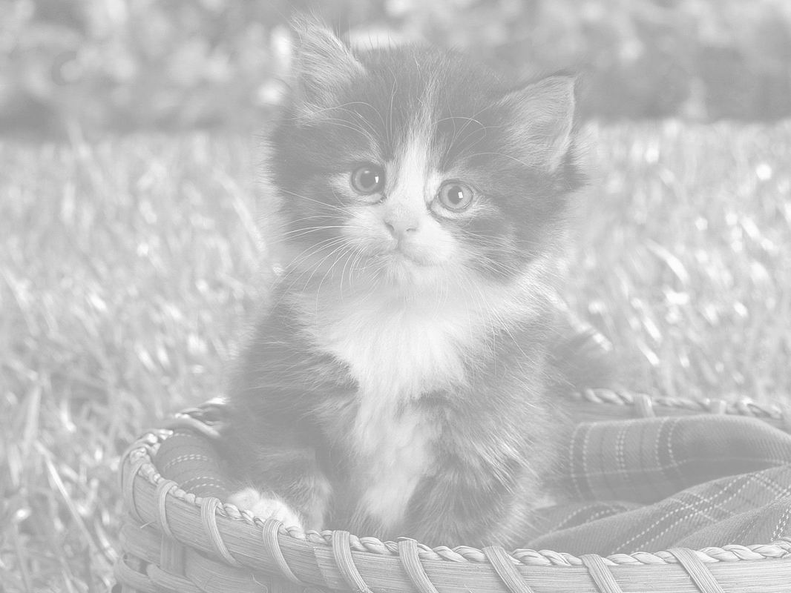

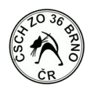

Czech breeders association – SCHK ZO 36-Brno
Cordially invites you to two-one-day
International Cat show which will be held

27. - 28. JUNE 2015
Brno, Veletrhy Brno – BVV, air-conditioned pavilon
GPS 49°11'17.398"N, 16°35'7.710"E

Invited judgers:
Mr. Martin Kabina (CZ) I.,II.,III.,IV., Mr. Marek Chadaj I.,II.,III.,IV.,
MUDr Mrs. Marie Perčynská Říhová (CZ) I.,II.,III.,IV.,
Mr. Jaroslav Pánek I.,III., Mrs. Zdenka Heiter II.,

Show entry forms: all show entry forms have to be completely filled in,
clearly written and have to be confirmed by the club (FIFe country member),
please attach proof of payment, use this adress for sending:

Ivana Koplíková

Kamínky 4, 634 00, Brno
E-mail: showbrno@seznam.cz, Mobil: 776 274 395

- please fill in your e-mail in show entry form
- for any missing information or coninformation which need verifying
by telephone you have to pay penalty +5 Euro

Please note that show entry form must submit a copy
Proof of payment show entry form without confirmation
Payment is not received

Closing date: 22.06.2015

- CANCELLATION until the closing date only

Class | One day | Both days
Class: 1,3,5,7,9,11(7–10 Months), 12 (4–7 Months) | 30€ | 50€
Class: 2,4,6,8,10,15 | 25€ | 40€
Class: housecats, veterans (over 7 years) | 20€ | 30€
Litter – double cage(min.3kittens over 4 months) | 50€ | 80€
Verification class – Class: 13a,b,cs | 10€ | xxx
Third and any other cats - discount | 5€ | xxx

Payment:
Nothing extra is changed. We accept pay in euro.

Registration after closing date +5 Euro for one cat and day

Show rules:
All FIFe show rules are valid and applicable. Attention change in Classes 11 (kittens 4-7 months), 12 (kittens 7-10 months). Exhibitors or persons authorized by them may present the cat to the judges themselves but a steward will be at their disposition. Throughout the exhibition cats have be kept in decorated cages. Cages are not numbered, each exhibitor will be find a cage by himself.
Participation is at risk of the exhibitor, no claims for damages will be accepted. All changes in classes must be announced to the show secretariat until 9:00 am. Early exit from the exhibition is possible only with the consent of the exhibition committee.
Chairs are not available.

Veterinary rules:
All cats must have a valid vaccination against rabies, respiratory viral diseases and panleucopenia marked by the veterinary surgeon on the pet passport. Primary vaccination have to be at least than 15 days prior to the show. White cats must be accompanied by the certificate that they are not deaf. All cats foreign countries must have a microchip and valid pet passport.

Show times:

07:30 – 09:00 - entry of the cats, vet control
09:00 – 09:30 - corrections
10:00 – 14:30 - judging
15:30 – 17:00 - Best In Show
18:00(So), 17:00(Ne) - end of the show
Accommodation: http://www.brnohotely.com/, http://www.onlinehotels.cz/, http://www.brnohotels.cz/, http://www.brnocity.cz/hotely/

We are looking forward to your visit! We are very happy, if you invite your friends too.
Show organisation team.

ZO Brno 36
www.zo36brno.cz

